THE HOUSING HORIZON
  - residents first!
Stay Put & Stay Informed: “Forward Virginia Plan”  Staying in touch with family and friends can be challenging. Staying connected is much harder when families are separated by miles. It is very important to maintain a connection with loved ones, especially during a period of crisis. Across our country, states and localities are experiencing and coping with different phases of the COVID-19 pandemic. Governors are seeking to do what is in the best interest of their constituents to keep them safe. However, some localities have begun to gradually return to their “normal” way of life.  Governor Ralph Northam announced a three-phase plan to get Virginia back up and running with his “Forward Virginia Plan.” Phase one of the plan was scheduled to start on May 15th. During this phase, social gatherings of 10 or more people are banned, social distancing is in effect, telecommuting is advised, and face masks are strongly recommended during public outings. Although some restrictions will be relaxed, we must continue to practice caution. The COVID-19 pandemic is still active and Executive Order 63 requires people 10 years and older to wear face covering while inside buildings open to the general public.  Under phase two, gatherings of more than 50 people are banned and wearing masks is still encouraged when outdoors. Some of the restrictions on businesses will be further eased. Phase three of the plan, which could still be weeks or months from now, will remove bans on social gatherings and capacity limits in businesses.  To learn more about Governor Northam’s executive orders, visit https://www.governor.virginia.gov/executive-actions/  To obtain the latest updates on COVID-19 and for tips on making cloth masks, cleaning and disinfecting your home, stress and coping, etc., please visit https://www.cdc.gov/  Residents First! |  | Business Hours:  500 South 1st Street  Monday-Friday, 8am-5pm; EXCEPT Wednesday 10am-5pm  (434) 326-4672  801 Hardy Drive  By appointment only.  (434) 326-4672 ext. 9308  Maintenance  (434) 227-2107  Non-Emergency Police  (434) 970-3280  Reminder: Please place rent payments in the drop box at the rental office. Receipts will be mailed out to confirm payment.
Where’s My Chromebook?  If you still need a Chromebook or help with accessing the internet, please reach out to your child’s principal. For more school information call, (434) 245-2400. | COVID-19 School Resources & Update  Charlottesville City Schools are closed for the remainder of the 2019-2020 school year following Governor Northam’s statewide school closure to contain the Coronavirus. Stay informed of important school updates related to continuity of learning and more by visiting http://charlottesvilleschools.org/coronavirus/
Remember to stay 6 feet apart from your friends when speaking to them.  Here Comes Summer, June 20th  Saturday, June 20th is the summer solstice. The summer solstice is when the sun reaches its highest position in the sky and is the day with the longest period of daylight. It marks the beginning of summer in the northern hemisphere.  If you are need of a mask, please contact the Rental Office. | Be safe! Stay inside!  Happy Father’s Day, June 21  The Father’s Day is celebration was brought by the Spanish and Portuguese to Latin America, where it is often still observed on March 19. Many countries throughout Europe and North Americas have adopted the U.S. date of observance, which is the third Sunday of June.
Meet Our Staff  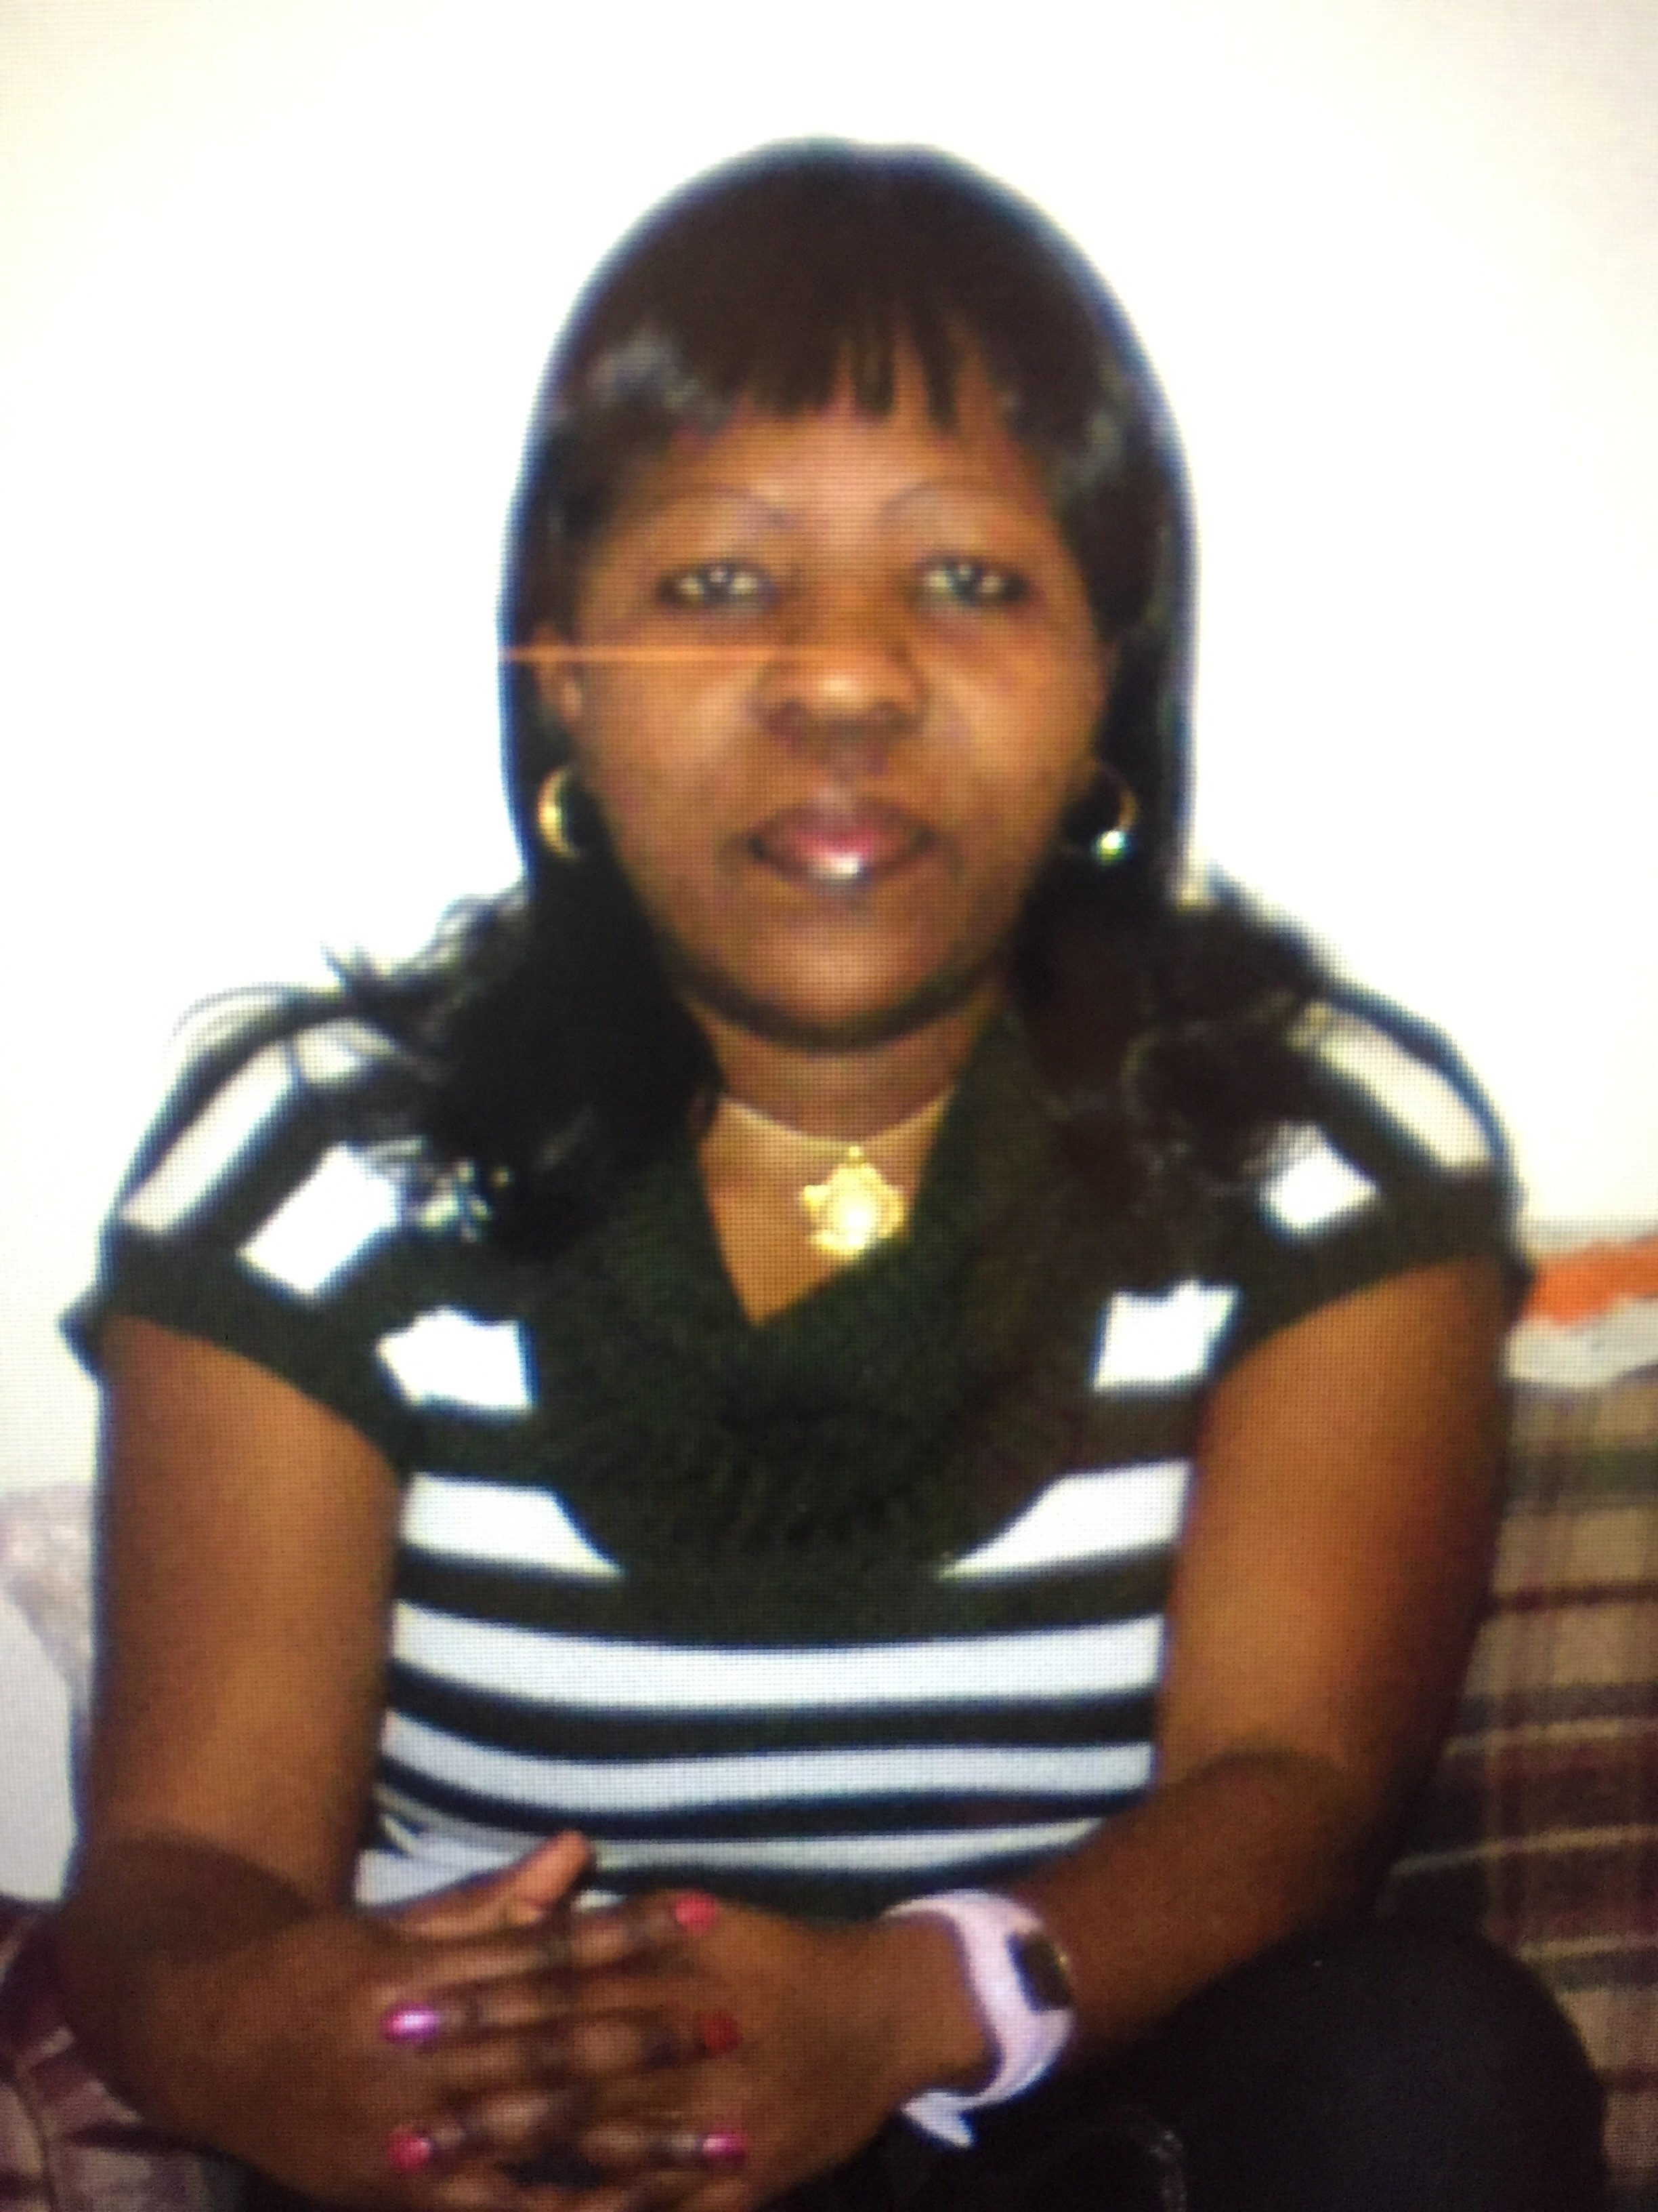  Perpetue Moumbossy was born in the Republic of Congo in Africa. She graduated from Marien Ngouabi University in Business/Accounting. Due to the civil war, she moved to the United States in 2007. She lived in Syracuse, NY for three years, moved to Harrisburg PA for 1 year, then relocated to Charlottesville in 2011.  Prior to CRHA, she worked as a care provider at ABC Preschool and as a French teacher at Mighty Minds Little Hands International Preschool. Also, she worked as a substitute teacher for the Charlottesville City Schools, and for the CLASS after school program.  She graduated in Management from Piedmont Virginia Community College. She was a public housing resident of the Westhaven Community and completed a PHAR Internship and Leadership Program.  She joined CRHA as an Assistant Asset Manager in November 2017. Currently, she is the Property Manager of the South First Street and 6th Street communities and the scattered sites.  She speaks French, English, Lingala, Munukutuba, and several other dialects. | Leslie Deane is a native of Spotsylvania County. She moved to Charlottesville to complete her undergraduate degree at the University of Virginia. After serving in a variety of positions at the University and in the non-profit sector, she made the Housing Authority her vocational home as the Administrative Assistant at the CRHA Rental Office.  Her interest in housing stems from taking a “Getting Started on Affordable Housing” training at the Virginia Housing Training Center, while employed as the Senior Information & Referral Specialist at the United Way. She has an extensive background in non-profit and human services roles.  She strives to provide exceptional customer service to clients, staff, and the community. Leslie assists CRHA’s team of housing experts by performing a variety of supportive tasks.  In her spare time, family comes first, followed by writing, art, piano and meditation. Her civic activities have included the Dept. of Social Services Advisory Board, the Albemarle Housing Advisory Board, Habitat for Humanity and the MACAA Board of Directors.

A MESSAGE FROM THE MAINTENACE DEPARTMENT - (434) 227-2107

On-Call Emergencies: Issues Requiring Immediate Response

Loss of power affecting kitchen and or bathroom (if only one bathroom)

Loss of heat to entire unit (only between Oct 15th & Apr 30th)

Lock outs—Must have ID and no children under 18 will be let into any unit without any adult.

Gas smell

Toilet clogged (only one toilet)

Sewer back up

Water leak (does not include dripping faucets or shower heads)

Inoperable refrigerator

Damaged door locks, and/or windows which could create a security risk for residents

Other circumstances that could cause a threat or harm to persons or property

All alarm calls

Vandalism

Loss of A/C (Crescent Halls) before 10:00pm (only between June 1st and Oct 15th)

Semi-Emergencies: A 24-hour response time will be provided on these calls. All semi-emergencies
that are called in after 12:00pm on Sunday will not be completed until Monday

Loss of hot water- if it does not affect heat

Loss of A/C (if provided by CRHA) after 10:00pm (only between June 1st-Oct. 15th)

In operable stove

Loss of power, which does not affect the kitchen or bathroom (if only one bathroom)

Non-Emergencies: These will only be responded to during regular office hours; from 8:00am to 5:00pm, Monday thru Friday.

NOTE: Move-ins are only allowed at Crescent Halls during normal business hours (8:00am to 5:00pm). the Asset Manager must give approval to move-in after hours or on a weekend.
Charges will apply to lockout and lost keys, changing locks, replacing broken windows, damaged screens, and closet doors.
Announcements:
- CRHA Regular Board Meeting, June Location: TBD.

